This is a screenshot of the URL-Shortener homepage after a successful build: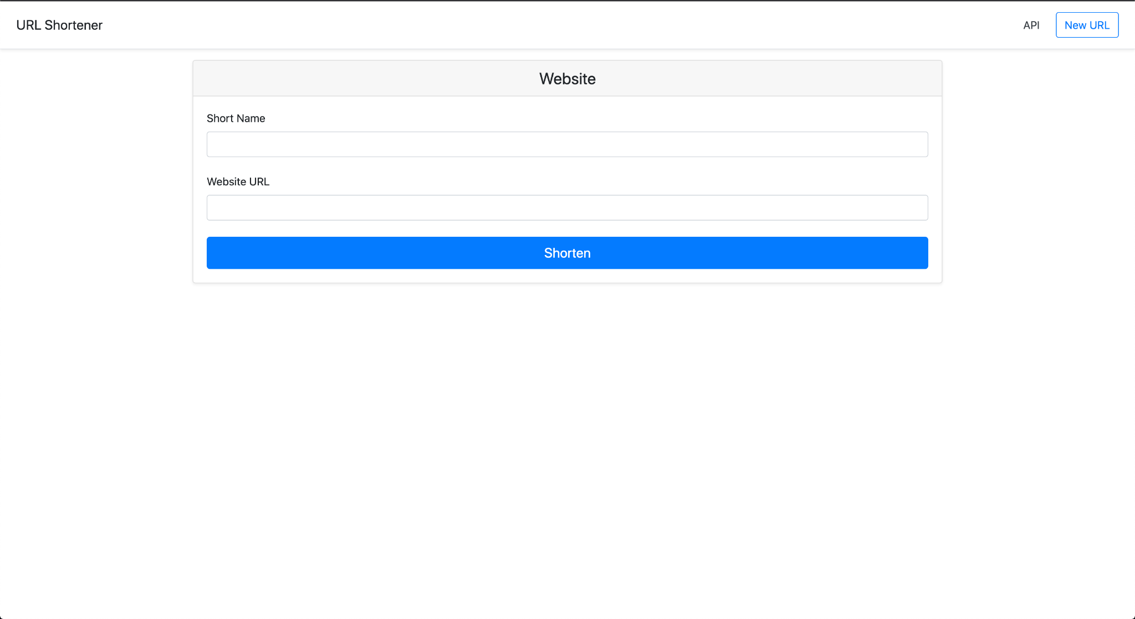

This is a screenshot of the successful build of my To-Do App:

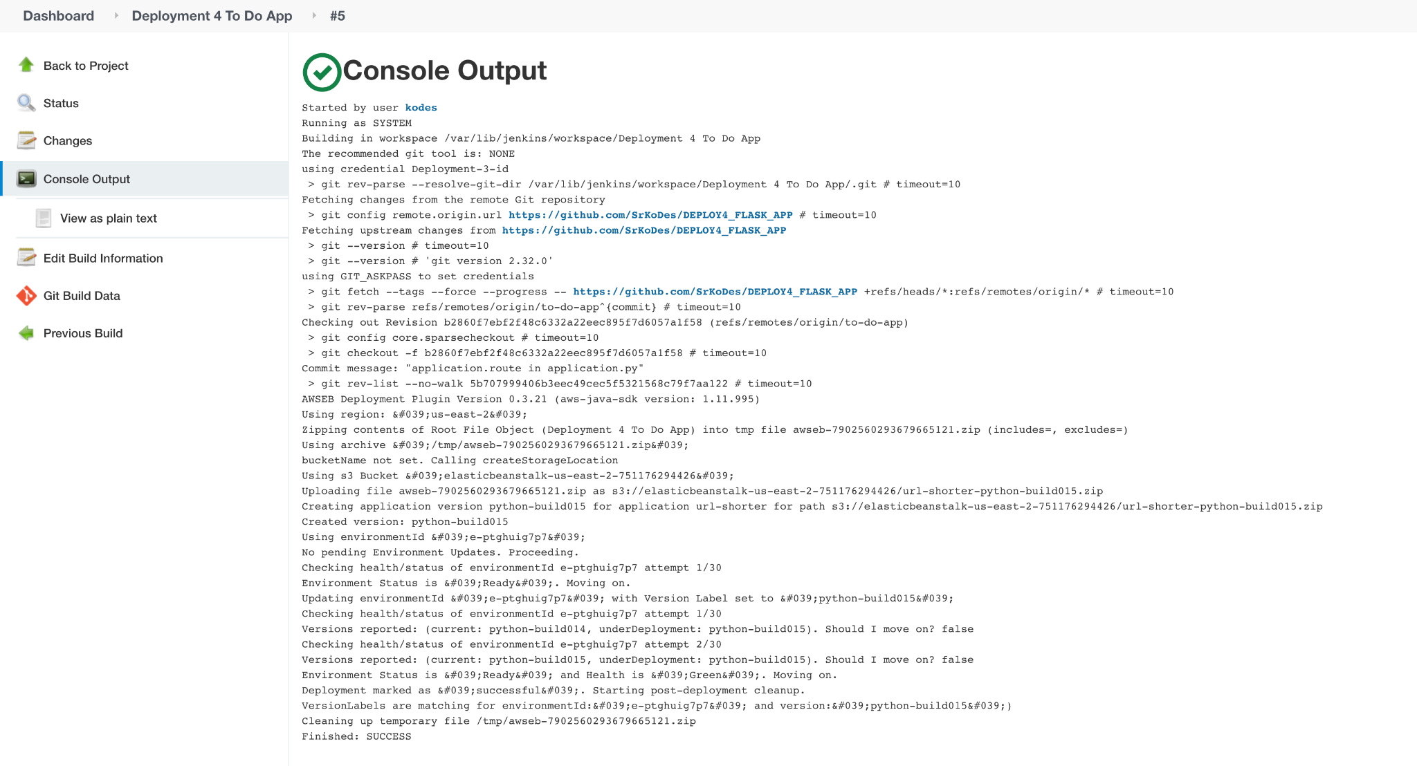

This is a screenshot of the homepage of my custom app after a successful build:

